**Monte-Carlo Simulation**

Generate distribution of 0.01 quantile (1% percentile) of 10-days overlapping proportional returns obtained from the 3-years timeseries (750 observations) of 1-day returns. Original timeseries is generated using stable distribution with the following parameters: alpha = 1.7; beta = 0.0; gamma = 1.0; delta = 1.0.

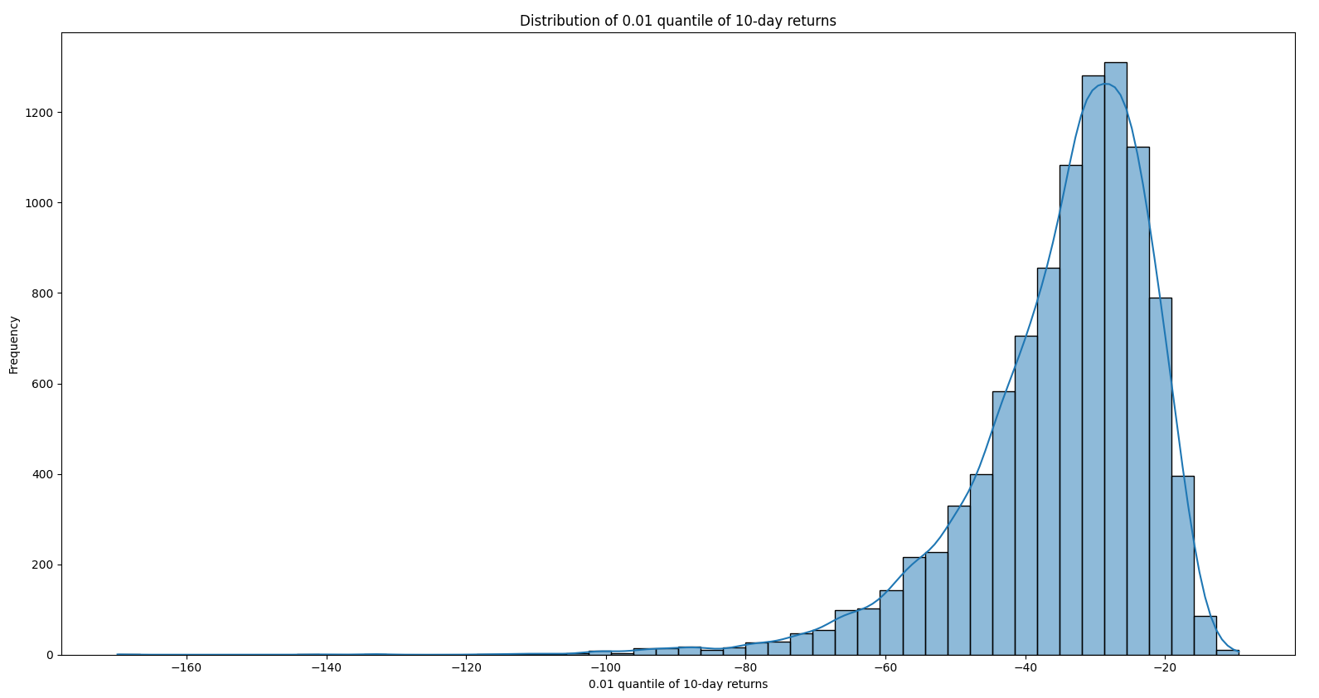

Show, either numerically or theoretically, that the chosen number of Monte-Carlo trials is sufficient.

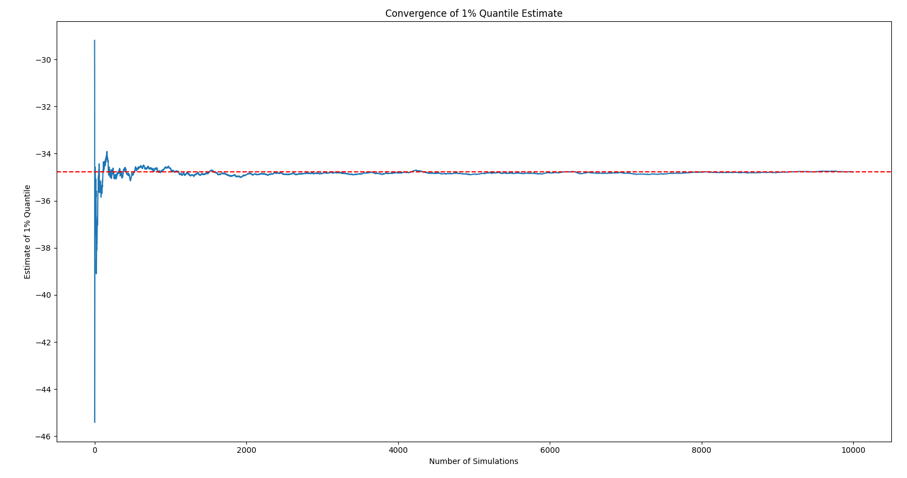

**Requirements**:

The task must be solved in R. Program code should be clearly written and well commented.

Code must be presented along with report comprising all necessary mathematical expressions, description of results and conclusions.

This report addresses the problem of time series modeling and analysis using stably distributed random variables and the Monte Carlo method.

Stable distributions have the important property of stability, which makes them particularly useful for simulations characterized by "heavy tails" and skewness. The main objective of this study is to estimate the 0.01 quantile of the distribution of 10-day returns, which is an important metric for risk management. To solve this problem, an algorithm in Python programming language was developed and applied, which includes generating time series, calculating returns and performing Monte Carlo simulations. The report also analyzes the sufficiency of the selected number of simulations to ensure the stability and accuracy of the results.

**Stable distributions** are a family of distributions that generalize the normal distribution and have the property of stability: a linear combination of two independent, identically distributed, stably distributed random variables has the same distribution as the individual variables. Stable distributions are introduced as limit distributions (meaning convergence in distribution) for the sum of identically distributed random variables. The most famous representative of this family is the normal distribution. Many methods of applied statistical analysis are based on it.

The whole class of stable distributions can be introduced through the characteristic function:



where , ,, - are unknown parameters.  defines the tails of the distribution, – asymmetry parameter,  is responsible for the scale and  – distribution shift parameter.

According to the problem statement: = 1.7; = 0.0; = 1.0; = 1.0. The function **levy_stable.rvs**, which generates random numbers from the Levy stable distribution, was used to generate a sample of random numbers from the Levy distribution with specified parameters. The Levy stable distribution is a generalization of the normal distribution and has four parameters. The time series generated to solve the problem is presented in Fig. 1. It is worth noting that stable distributions have heavy tails, which means that they can generate values with large deviations from the mean. Depending on the parameters of the distribution, such strong departures can be quite typical. The corresponding probability density distribution is shown in Fig. 2.

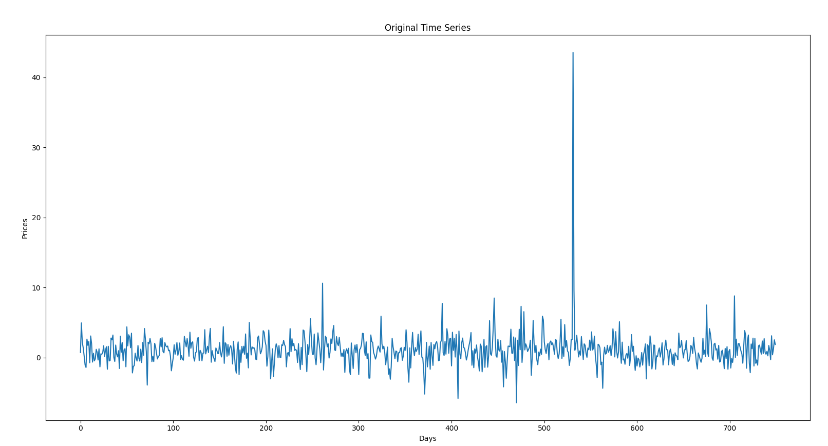

Figure 1 – Time series using a stable distribution

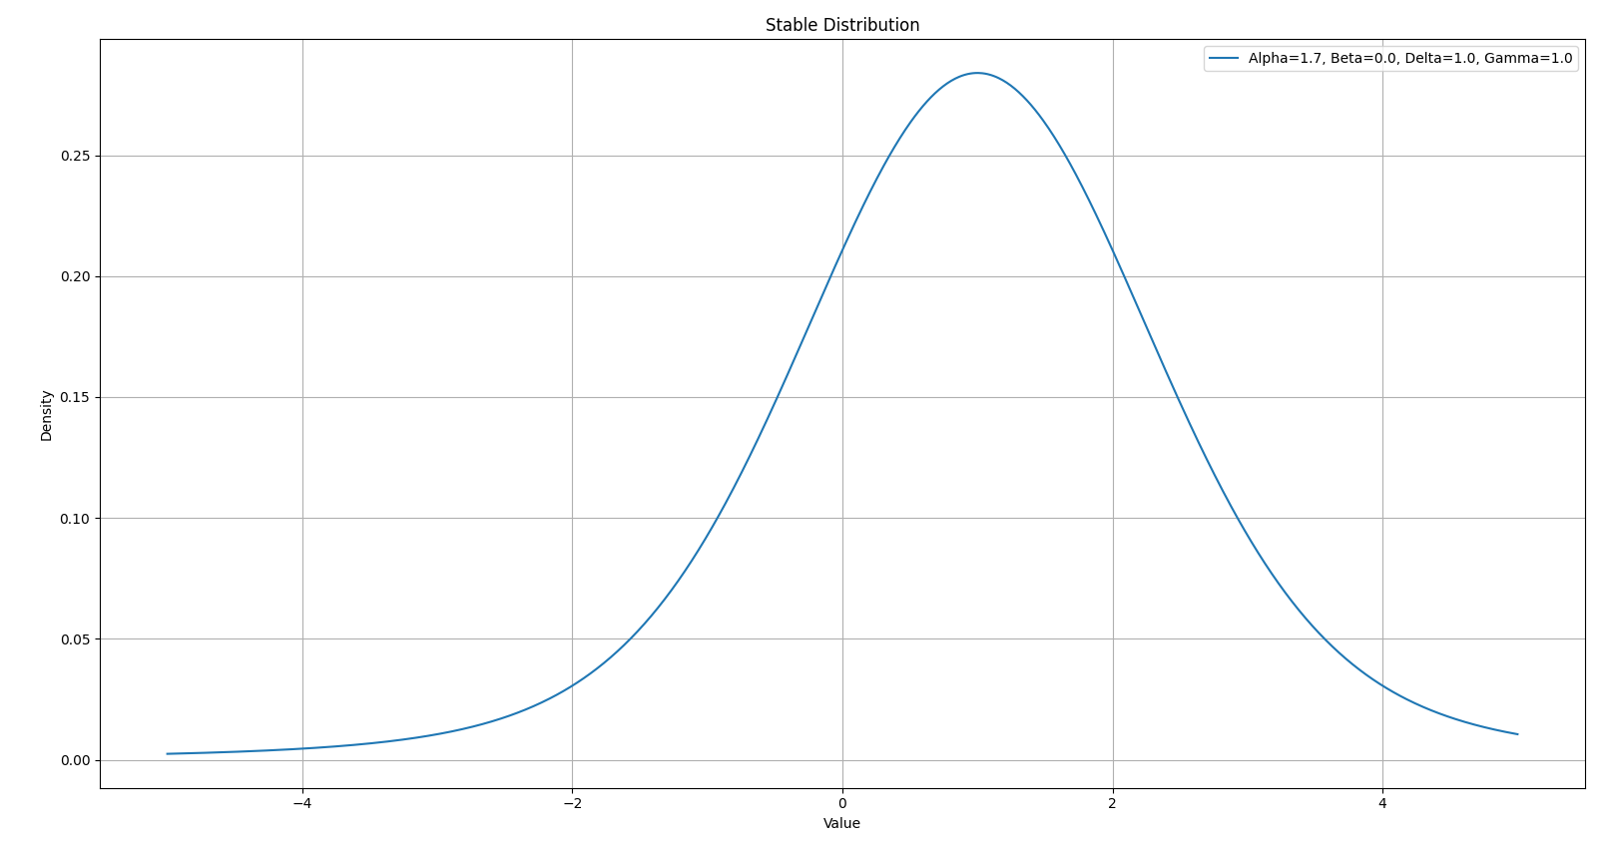

Fig. 2 – Probability density function of the stable distribution

(= 1.7; = 0.0; = 1.0; = 1.0)

After generating a time series of 750 observations, we calculate the returns for one day:



Similarly, we will get the yield for 10 days:



Since the 1-day return is defined as the difference between the stock price on the next day and the current price, divided by the current price (2), and the 10-day return is defined similarly (3), we can express the 10-day return in terms of the 1-day return as follows:



Next, it is necessary to generate a set of realizations of the time series and calculate the corresponding 10-day returns. Modeling was carried out on the basis of the Monte-Carlo method. Monte-Carlo is a method of analysis used when parameters are known approximately and there is information about statistical distribution of these parameters. To perform the analysis, a large number of random parameter values are generated, for each such value the calculation is performed and the statistical distribution for the result is formed.

As can be seen from the histogram presented in Fig. 4, the most frequent value of 0.01 quantile of 10-day returns lies between 20 and 40.

Thus, based on Monte Carlo simulation it is obtained that:

1. **Mean of 0.01 quantile: -34.78403715522337**
2. **Standard deviation of 0.01 quantile: 13.27101320458005**



Fig. 3 – Distribution of 0.01 quantile of returns for 10 days in Monte-Carlo simulation

The study of the convergence of the sought value, which is presented in Fig. 5, confirms the fact that the results obtained in the course of the work have satisfactory accuracy, and the number of Monte Carlo tests is sufficient.



Fig. 4 – Convergence of 0.01 quantile in Monte-Carlo simulations